**The Lost Mine**

Before entering, the PCs will have a chance to roll Dungeon Lore (DL 10). If they succeed, they get a quest:

***Reclaim the Lost Mine I***

* *Destroy the Statue of Gonoltha*
* *Defeat the Forgemaster*
* *Defeat the Goblin Priest*

**Level One**

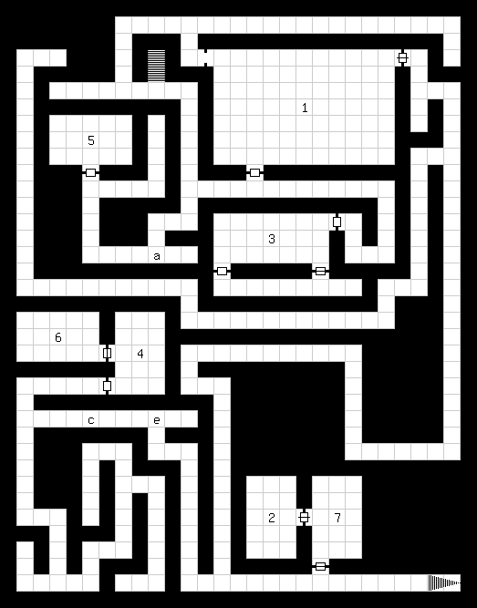

***General***

The first floor of the Lost Mine is the home of the Spider Cult, which is made up of goblins and their pets. The walls are rough-hewn stone with wooden supports. Doors are heavy wooden doors built into a set of supports.

Dead ends are typically “test tunnels” where miners would hunt for ore veins.

**Marker “a” – Pit Trap**

A pit trap is here to catch the unwary. The trap is pretty simple – DL 8 to circumvent.

**Room 1 – Abandoned Work Area**

This entrances to this room are blocked by signs, crossed spears, and piles of rocks. The signs are in goblin (Language DL 10) and read “Runty Skellies: Keep Out.”

When you enter the room, you see an abandoned work area. There are tools and mine carts and piles of debris. Strewn about the mine are a dozen desiccated corpses of the dwarves who worked here before the cult invaded.

After a few moments in the room, the corpses rise from their rest and attack with picks and shovels.

***Dwarf******Skeletons (12) – CV 10, T6/W6/C6, HP 12, HCAL 0000, DG 2d4+1, Loot 1d8G/Ess (Undead/1)***

* *Undead – Cannot be wounded, dazed or stunned*
* *Mindless – Immune to spells that affect the mind, or trick*
* *Rusty Tools – Tools have a 3/12 chance to break off and impale the target (Impair or Bleed)*

There are 15 wood resources, 10 stone, and 20 metal resources here.

**Room 2 – Treasure Room**

Not sure yet

**Room 3 – Goblin Temple**

Noises of physical labor can be heard coming from this room. Someone is working hard here.

When you enter, you see four goblins moving a large gong onto the altar of a large spider goddess. Once the goblins notice you, they turn to attack.

Any battle in here will be considered noisy, and might alert additional goblins guarding the door to room 5.

***Goblins (4) – CV 10, M12/T11, HP 22(6), HCAL 1111, DG d4+d6+1, Loot 3d6/Ess (Goblin/1)***

Monster or World Lore (DL 10) will tell PCs that the altar is dedicated to *Gonoltha*, a huge spider that lurks in the depths of these mines. The goblins bring the giant spider fresh victims and the spider weaves them sticky silken nets to better capture prey. It is said that to see her is to know true fear. (Can give a couple details from her monster stat sheet below.)

**Room 4 – Goblin Forge**

This room contains a fully-functional forge for creating weapons. It is of goblin make and any weapons made here will have the “Goblin” prefix, (-1 Accuracy, -1 Durability, +1 Damage).

There are also 15 metal resources, and 4 cloth resources to be plundered.

If PCs spend some time here, they will hear loud, thumpy footfalls coming down the hall. The Forgemaster will arrive and start working, unless he spots someone in his forge. Then he will attack.

***Forge Master – CV 12, M16/T14, HP 32(8), HCAL 0222, DG d4+d8+1, Loot (special)***

* *Resist Fire – The FM’s apron has the Resist Fire trait, giving +4 saves, -2 proc, -1 dmg/die*
* *Hammer Dip – The FM dips his hammer in the hot coals, giving his attacks Burn (3)*
* *Sweep – Take -2 to hit and swing at up to 3 adjacent opponents*
* *Stunning Blow – If the FM hits your head, you are stunned 1 round*

**Room 5 – Prison**

Two goblins guard this room. They are similar to the goblins in room 3, but they also carry nets.

***Goblins (2) – CV 10, M12/T11, HP 22(6), HCAL 1111, DG d4+d6, Loot 3d6/Ess (Goblin/1)***

* *Net – Save vs. Reflex (DL 12) or become Entangled. Save every round vs. Muscle to escape.*

The door beyond the guards is locked and opens to a dirty prison cell. Inside is a beaten and battered dwarf named Dondur.

***Dondur – CV 11, M12/T12/S12, HP 28(7), HCAL 0000, DG d6+weap, Loot 0/Ess (Helpless Prisoner???)***

Dondur and his companions entered the mines with the hope of liberating some of the riches here from the goblins. They ended up captured. The rest of Dondur’s crew has been taken down to the deepest level of the mines to be a sacrifice to the goblin’s spider goddess. Dondur will ask for the PCs’ assistance to save his friends. (Though this quest has a warning on it, since PCs might be too weak to descend into the depths.)

**Room 6 – Storage**

The goblins store their loot here. There are 50 tools here (L, sell for 5G) and 20 food resources.

**Level Two**

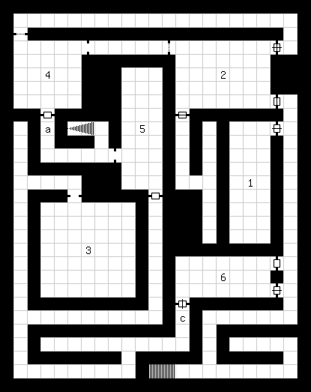

**Level Three**

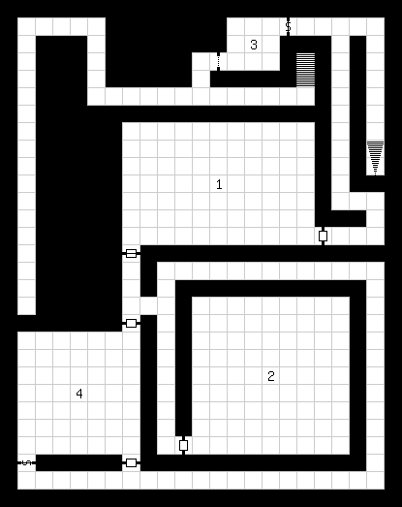

***Gonoltha – CV 14, M14/R12/S12/T16/W12, HP 41(10), DG 2d6, Loot ???***

* *Eight Eyes – Cannot be flanked or surprised in battle*
* *Know True Fear – When you first see Gonoltha, save vs. Power (DL 14) or be Stunned for 1 round, then Dazed for 1 round, then Cursed*
* *Poison Bite – Each bite, save vs. Toughness (DL 14) or suffer Venom (2)*
* *Poison Spittle – Spit into 1 hex, save vs. Reflex or Toughness (DL 14) or take 2d4P poison damage and suffer Venom (2)*
* *Web – Shoot web in 3 hexes, save vs. Reflex (DL 14) or be Entangled, can save Muscle or Reflex each round after to escape*